Guideline for extracting data from Area Health Resource File application:

List of Variables:

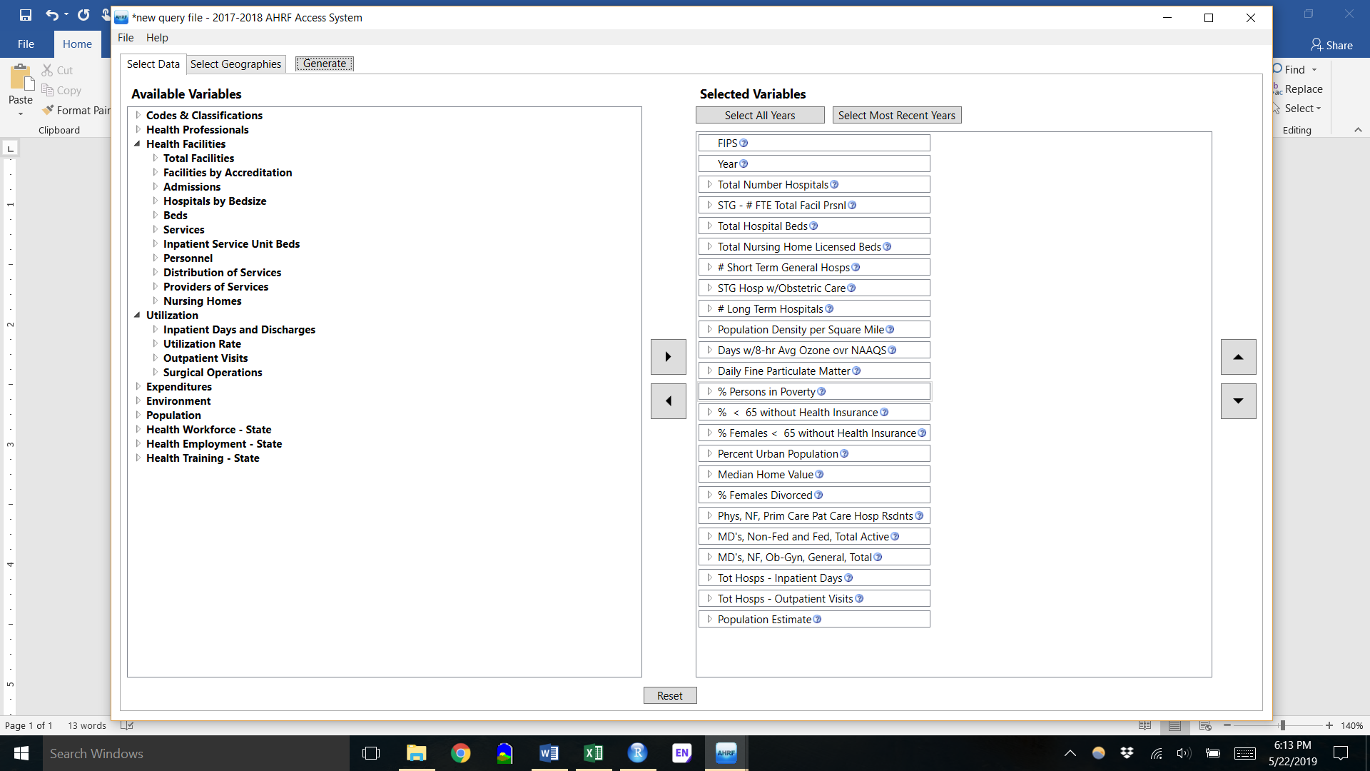

Definition of variables that might be hard to guess or find:

|  |  |
| --- | --- |
| **STG - # FTE Total Facil Prsnl** | Short term general hospital, Full Time Equivalent Facility Personnel |
| **Days w/8-hr Avg Ozone ovr NAAQS** | Over The National Ambient Air Quality Standard (NAAQS) |
| **Phys, NF, Prim Care Pat Care Hosp Rsdnts** | Physicians, Non-Federal, Total Patient Care, Hospital Residents |

**Note1:** To find the “MD's, NF, Ob-Gyn, General, Total”, you should go to the “Health Professionals” -> MDs by specialty (Surgical) and Major Professional Activity.

**Note1:** You also have to choose 2010, 2016, 2012-2016 as years and then filter them out in the Excel file.